Project Design Phase-II
Data Flow Diagram & User Stories

Date | 31 January 2025
Team ID | LTVIP2026TMIDS86052
Project Name | Smart Sorting: Transfer Learning for Identifying Rotten Fruits and Vegetables
Maximum Marks | 4 Marks

Data Flow Diagrams:
The Data Flow Diagram (DFD) for the Smart Sorting: Transfer Learning for Identifying Rotten Fruits and Vegetables project illustrates how data flows through the system from image input to prediction output.
The process begins when the user uploads an image of a fruit or vegetable through the web or mobile interface. The uploaded image is sent to the preprocessing module, where operations such as resizing, normalization, noise removal, and format conversion are performed to prepare the image for analysis.
After preprocessing, the processed image is forwarded to the trained transfer learning model. The model is built using a pre-trained convolutional neural network such as:
- ResNet50
- MobileNetV2
- VGG16
The model extracts important visual features such as color variation, texture patterns, mold presence, dark spots, and surface damage to determine whether the fruit or vegetable is Fresh or Rotten.
Once classification is completed, the system generates:
- Prediction result (Fresh / Rotten)
- Confidence score (%)
The result is then sent to the output module and displayed on the application interface. The system may also store uploaded images and prediction results in a database for history tracking and model improvement.
This DFD clearly represents how input image data is transformed step by step into meaningful classification output, showing interaction between:
- User
- Web Interface
- Backend Processing
- Machine Learning Model
- Database
- Final Output

Example: Smart Sorting: Transfer Learning for Identifying Rotten Fruits and Vegetables

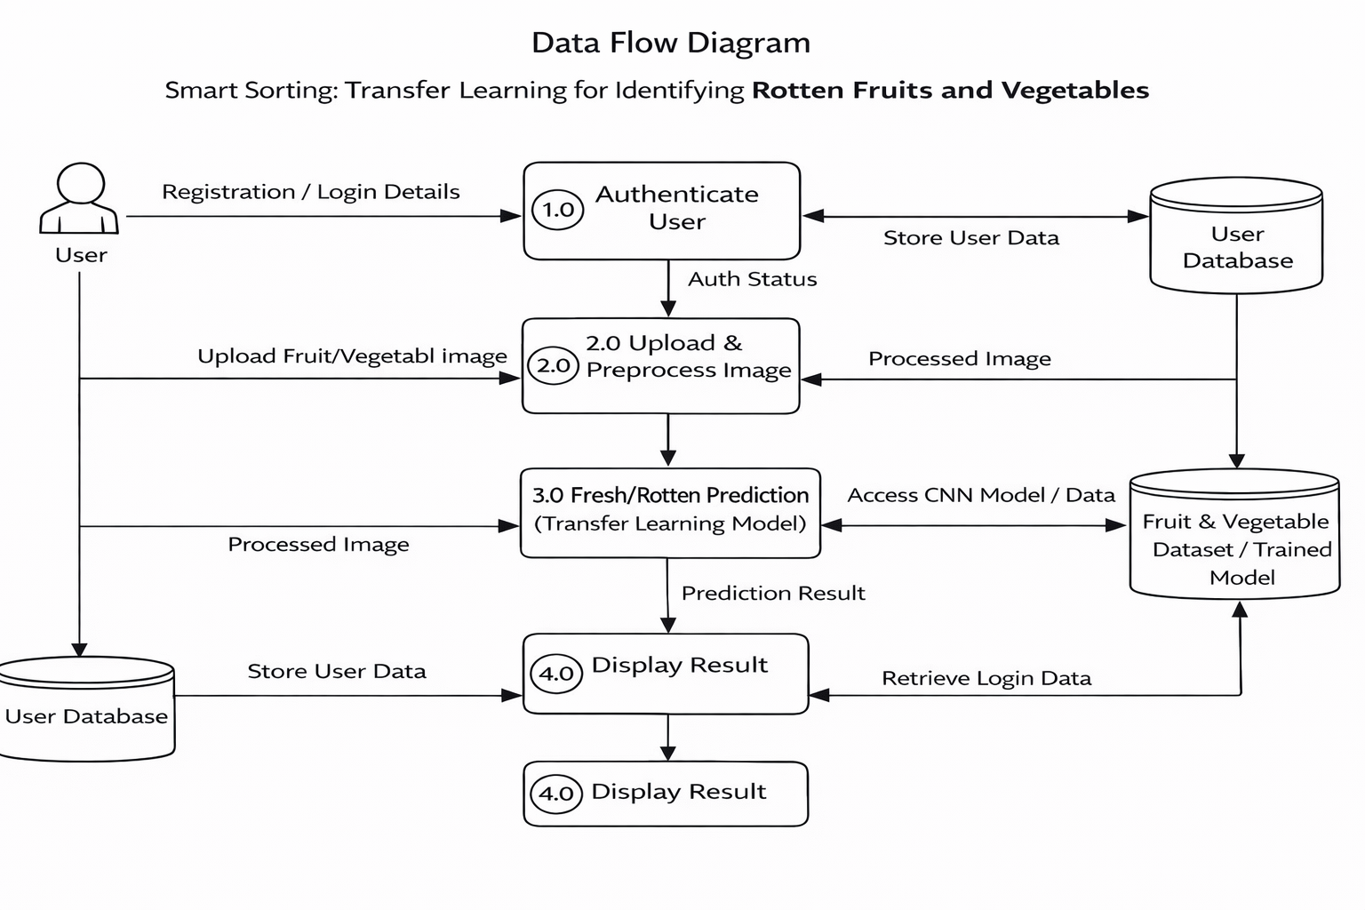

User Stories
Use the below template to list all the user stories for the product.
User Type | Functional Requirement (Epic) | User Story Number | User Story / Task | Acceptance criteria | Priority | Release
Customer (Mobile user) | Registration | USN-1 | As a user, I can register using email and password. | User can access dashboard after successful registration. | High | Sprint-1
 |  | USN-2 | As a user, I will receive confirmation email after the registration | User clicks confirmation link and account gets activated. | High | Sprint-1
 | Login | USN-3 | As a user, I can register for the application through Facebook | User can register & access dashboard via Gmail. | Medium | Sprint-1
 | Image Upload | USN-4 | As a user, I can upload fruit/vegetable image from gallery | Image uploads successfully and preview is shown. | High | Sprint-1
 | Fresh/Rotten Prediction | USN-5 | As a user, I can click “Predict” to classify  freshnes | System displays Fresh/Rotten result with confidence score. | Medium | Sprint-2
 | Result Display | USN-6 | As a user, I can view detailed result with  probability score. | Prediction and percentage confidence are shown clearly. | High | Sprint-1
 | History | USN-7 | As a user, I can view previous predictions. | History page displays stored predictions. | High | Sprint-1
 | Share Feature | USN-8 | As a user, I can share prediction results. | Sharing option works via link/social media. | High | Sprint-1
Web User | Registration & Login | USN-9 | As a web user, I can register and log in. | User accesses dashboard via browser. | Medium | Sprint-2
 | Image Upload | USN-10 | As a user, I can share prediction results. | Share option works via social media or link. | Low | Sprint-3
 | Prediction | USN-11 | As a web user, I receive freshness classification. | Fresh/Rotten result displayed with confidence score | High | Sprint-1
 |  | USN-12 | As a web user, I can upload dog images. | Image is successfully processed and preview shown. | High | Sprint-1
Administrator | Model Management | USN-13 | As an admin, I can upload updated trained models. | New model replaces old model without system failure. | High | Sprint-2
 | Dataset Management | USN-14 | As an admin, I can manage fruit/vegetable dataset. | Dataset updates reflect in model training. | Medium | Sprint-2
 | User Management | USN-15 | As an admin, I can view and manage users. | Admin can activate/deactivate user accounts. | High | Sprint-2
 | Monitoring | USN-16 | As an admin, I can monitor system performance. | Dashboard shows usage statistics & logs. | Medium | Sprint-3
Customer Care Executive | Support |  | As a support executive, I can view user issues. | Support dashboard displays complaints & queries. | Medium | Sprint-3
 | Feedback |  | As a support executive, I can record user feedback. | Feedback is saved and visible to admin. | Low | Sprint-3

